Paper Review of Cheng by 06/26/2020

* Title: Geohash Index Based Spatial Data Model for Corporate
* Needs
  + Because the data on the map is discrete and unrelated to each other, it is very time-consuming to store, modify and query the data in the database.
  + The geospatial data scale is large, and the information collected will be very large
  + Because the GPS data is not accurate enough, so many times you need to find the results within a certain error range in the database.
* Objectives
  + Search all results within a certain range with very low time complexity.
  + The data in the database should be easily added, deleted, modified and searched.
* Methodology
  + Authors design a method to make a spatial data management model, using spatial indexing structure and algorithm.
  + A region division method is designed, and the global range is represented as different regions by using binary digit strings.
  + And the number strings between each adjacent area are related, which means that whether the two areas are adjacent can be judged by the number string.
  + Depending on the number of digits in the digital string, the accuracy can range from kilometers to millimeters.
* Results

Separate global longitude and latitude with binary string

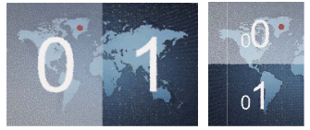

Use adjacent binary strings to represent adjacent areas

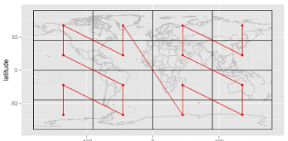

This structure and algorithm are used in Google Maps and Uber vehicle search now.

* Conclusion
  + The author has designed a spatial indexing algorithm, which can efficiently store the coordinate information in the global range into the database, and can find the collection of required information in a specific area.